**MODULE: 5 (jQuery Basic, Effects & Advance)**

**Q-1. What is jQuery?**

**Ans-1. jQuery is a lightweight, "write less, do more", JavaScript library. The purpose of jQuery is to make it much easier to use JavaScript on your website. jQuery takes a lot of common tasks that require many lines of JavaScript code to accomplish, and wraps them into methods that you can call with a single line of code. jQuery also simplifies a lot of the complicated things from JavaScript, like AJAX calls and DOM manipulation.**

**Q-2.  How to Apply CSS Using jQuery, How to Add Class and Remove Class in jQuery, jQuery Animation?**

**Ans-2.**

**Add class Example:-**

**Code:-**

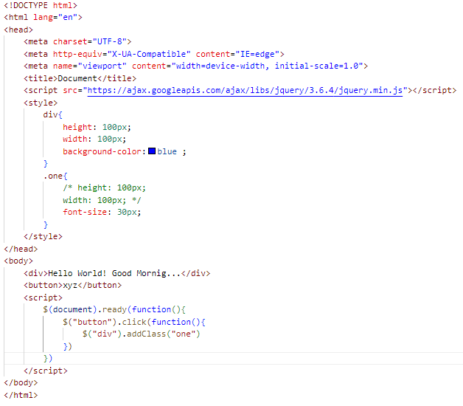

**Output:-**

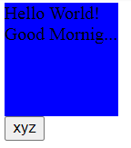

**Add class and change css:-**

**Output:-**

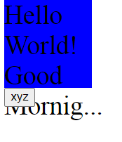

**Remove Class:-**

**Code:-**

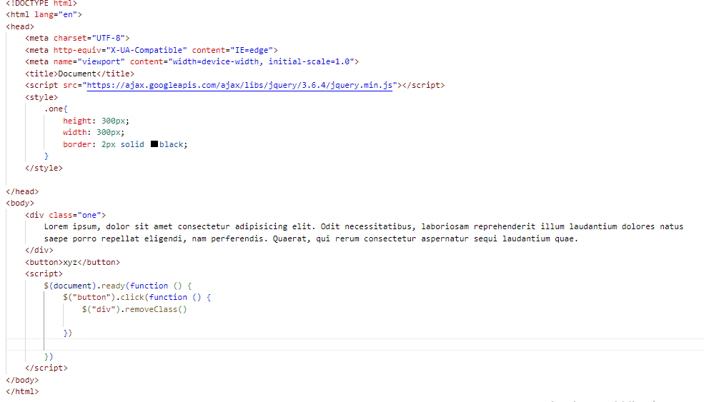

**Output:-**

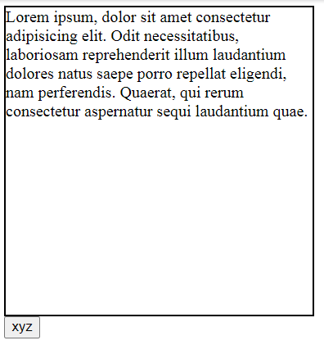

**Remove class and remove css:-**

**Output:-**



**jQuery Animation:-**

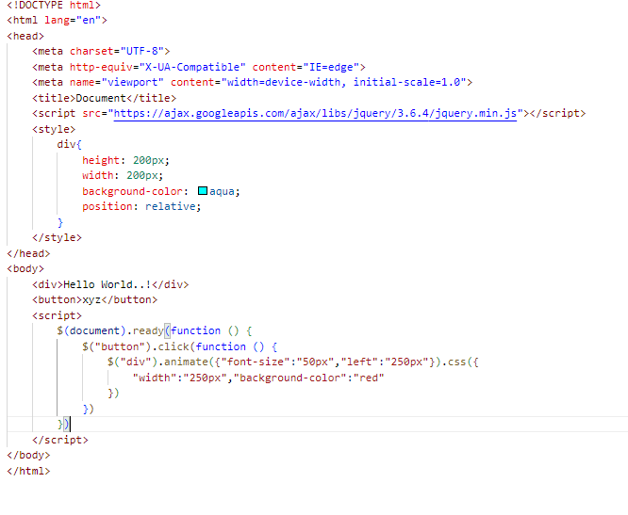

**Output:-**

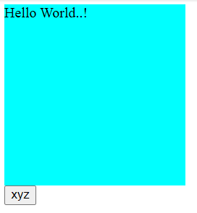

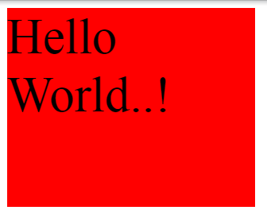

**Q-3. How to create slider with animation?**

**Ans-3.**

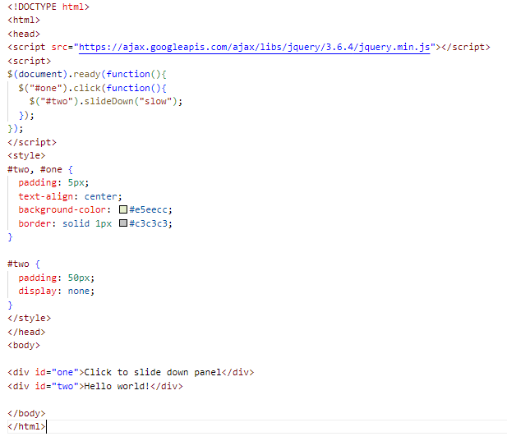

**Output:-**



